

**Abu Dhabi**

United Arab Emirates

**+971544049099**

[Email: info@blackoutae.com](mailto:info@blackoutae.com)

HOME

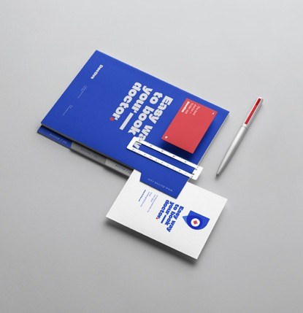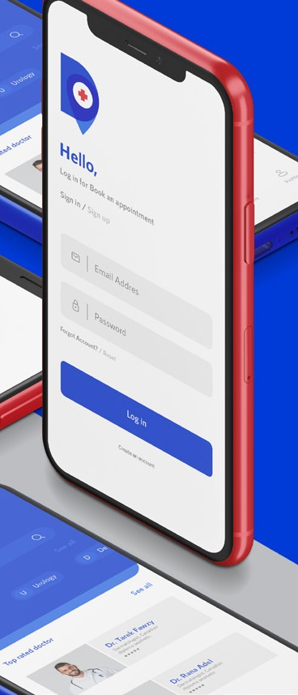

We are building brands

**Home About Work Contact**

Doctive

**Your doctor finder**

01/04

**The Lady’s Cabinet**

Where all your secrets are!

**NutCrackers**

We are nuts you are not

**Doctive**

Your doctor finder

**Roasi**

More than coffee

**Abu Dhabi +971544049099**

United Arab Emirates [Email: info@blackoutae.com](mailto:info@blackoutae.com)

© 2021 Blackout Agency. Privacy Policy Terms & Condition

ABOUT



**Abu Dhabi +971544049099**

United Arab Emirates [Email: info@blackoutae.com](mailto:info@blackoutae.com)

© 2021 Blackout Agency. Privacy Policy Terms & Condition

The value you get from blackout, and the one you give it to your audience.

**Details create the big picture; Stars together build a whole sky!**

This is what we believe, everything we create is touched with value! We complete your vision with value!

Values

**that helps your,**

Business to achieve a competitive edge? Whether it is a rebranding of an existing brand or building an identity from zero! Blackout is ready for the mission! We work with everyone, build a whole world from nothing!

everyone.

We work with **Interested in a brand**

**We make**

**everything differently,**

And make the difference itself! we are not just brand builders, we are the mirror that reflects you in a different, extraordinary, and distinctive brand. A brand that tells a story, stock in minds, and makes the difference!

We do it differently!

**What we do?**

We create brands that all of us love and belong to! we do it perfectly as we think a lot, cook your thoughts, define your character, and finally build your identity! We give you a name, term, symbol, visual identity &amp;

long-lasting Mark!

**We are**

**brand builders,**

Working hardly in the dark like bats, to get your brand shine!

Building Brands and gave it some life to glare out is what we master in,

**Blackout!**

About

**Capabilities**

Strategy/Identity/Brand Design/Innovation/ Packaging/ Naming/Copywriting/Web Development/And More!

**We are brand builders** working hardly in the dark like bats

**Home About Work Contact**

WORK



**Home About Work Contact**

**Our Work**

**The Lady’s Cabinet**

Where all your secrets are!

**NutCrackers**

We are nuts you are not

**Doctive**

Your doctor finder

**Roasi**

More than coffee

**Let’s talk**

Our coffee is always ready, get in touch, And kick start your brand with us!

**Abu Dhabi +971544049099**

United Arab Emirates [Email: info@blackoutae.com](mailto:info@blackoutae.com)

© 2021 Blackout Agency. Privacy Policy Terms & Condition

**Get in touch**

CONTACT



**Home About Work Contact**

**Get in touch**

**First Step!**

Our coffee is always ready, get in touch, And kick start your brand with us!

**Abu Dhabi**

United Arab Emirates

**Phone New Business**

+971544049099 [info@blackoutae.com](mailto:info@blackoutae.com)

**Follow us on social**

**Don't be shy!**

Get in touch & Let your brand journey begin!

Name

Email

Phone No.

Subject

Your message

**SEND**

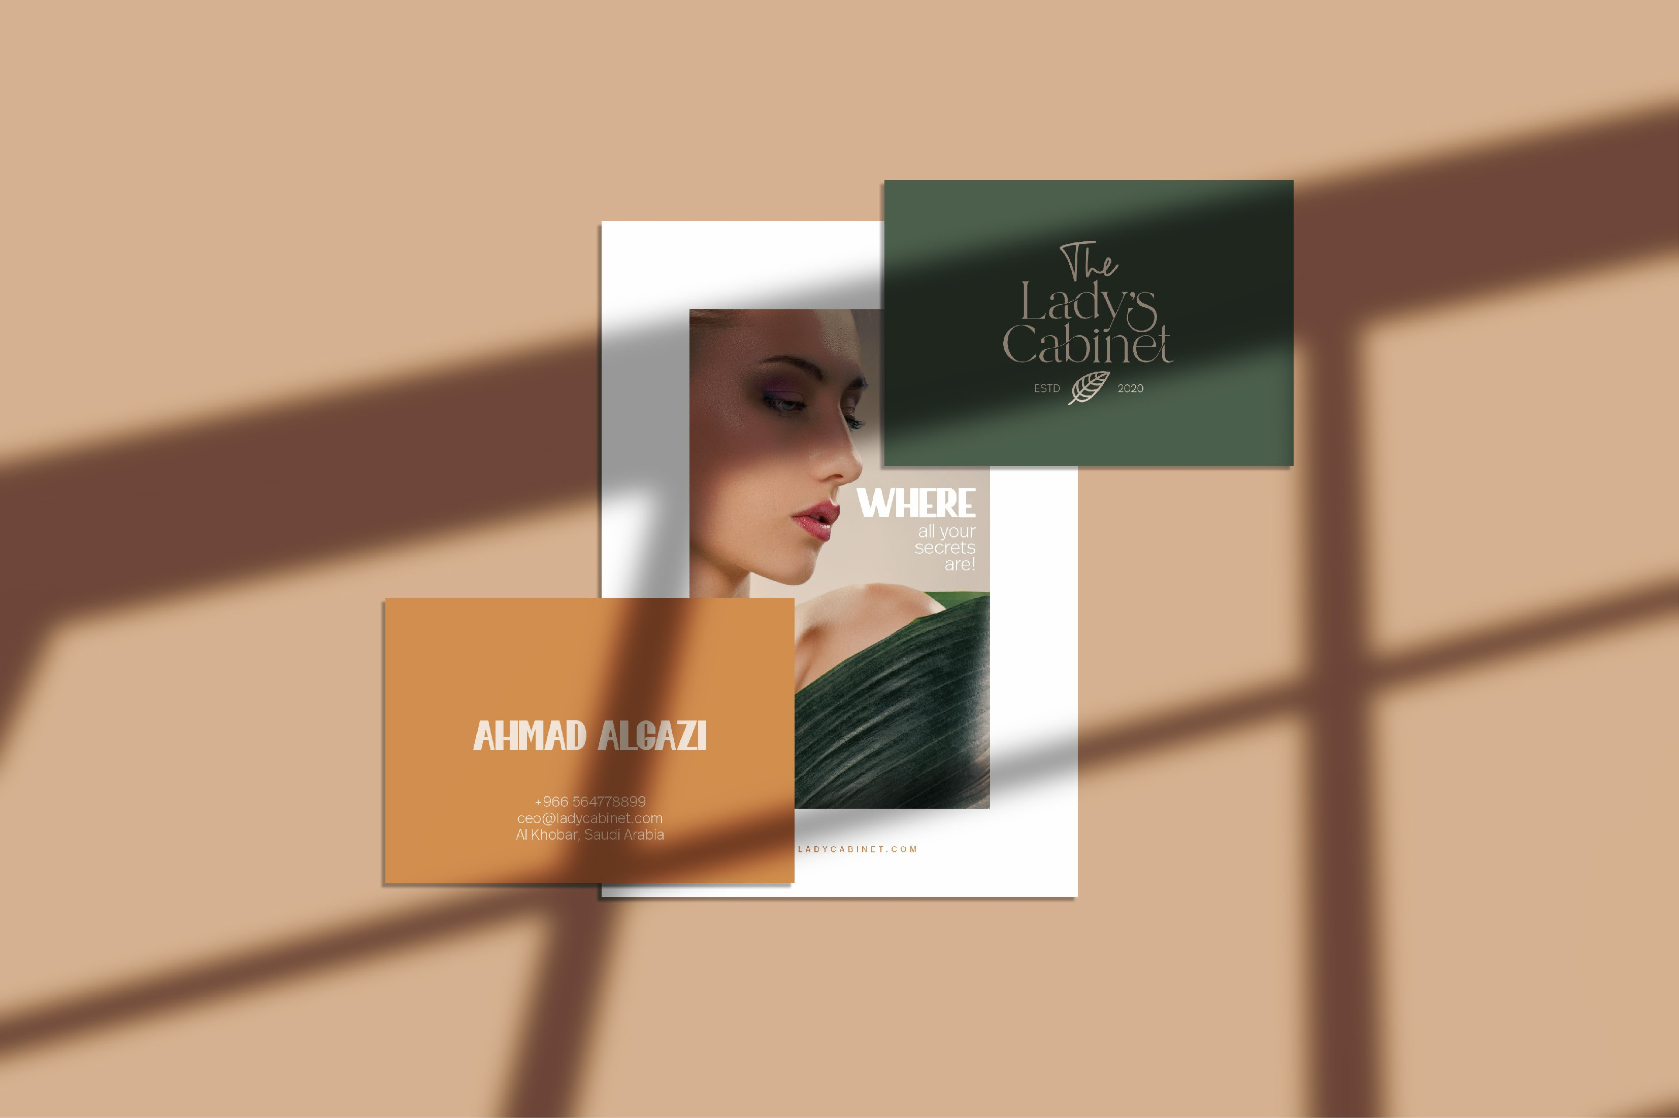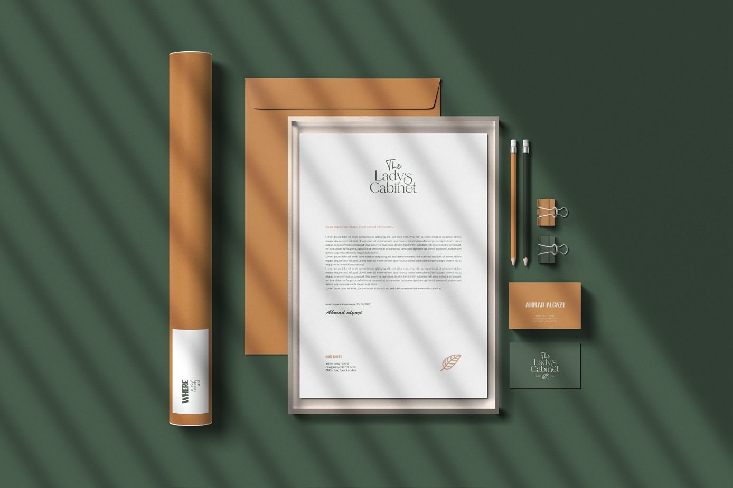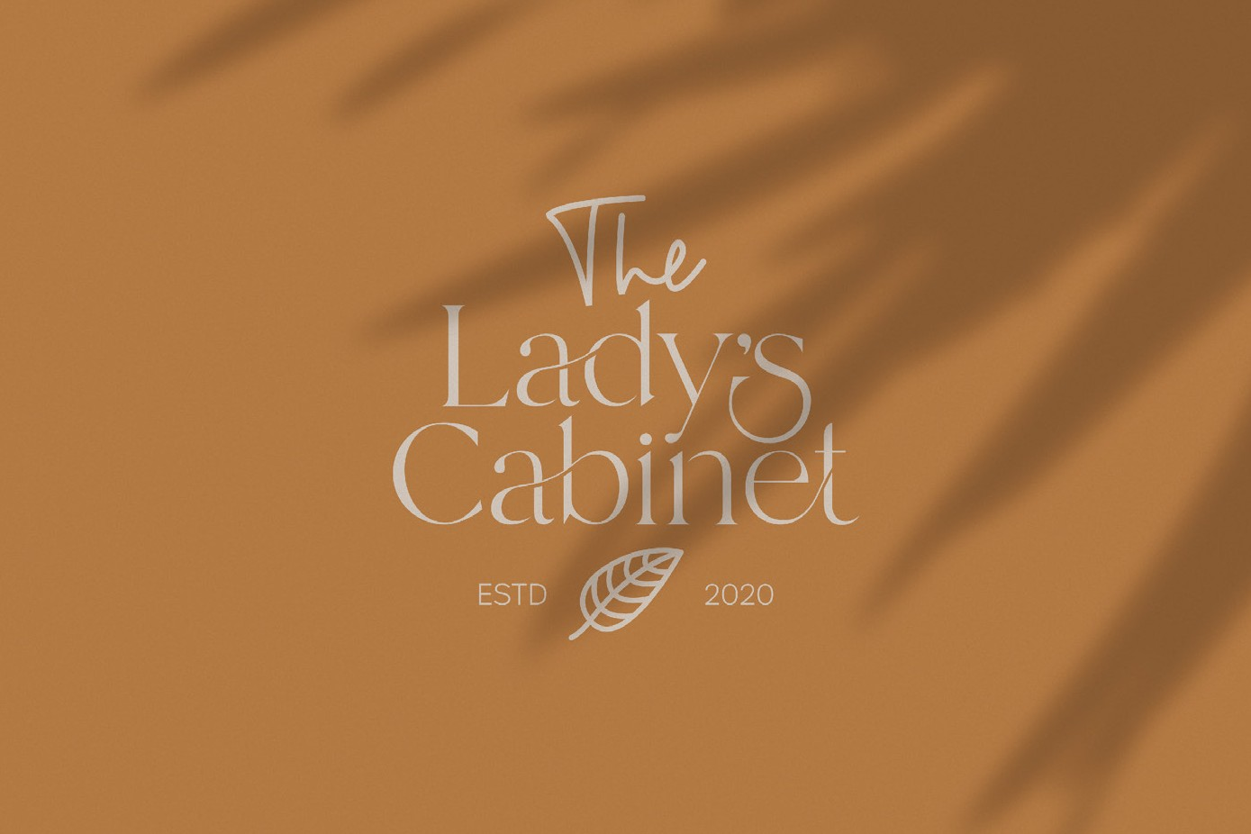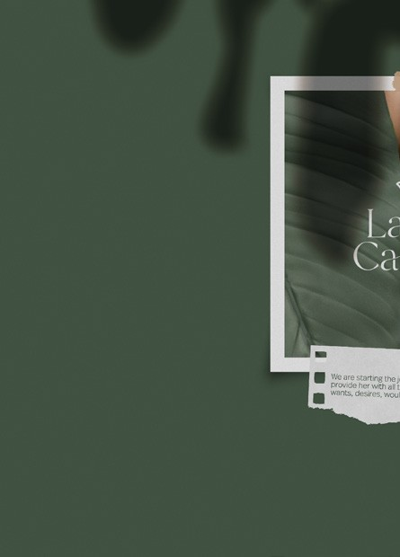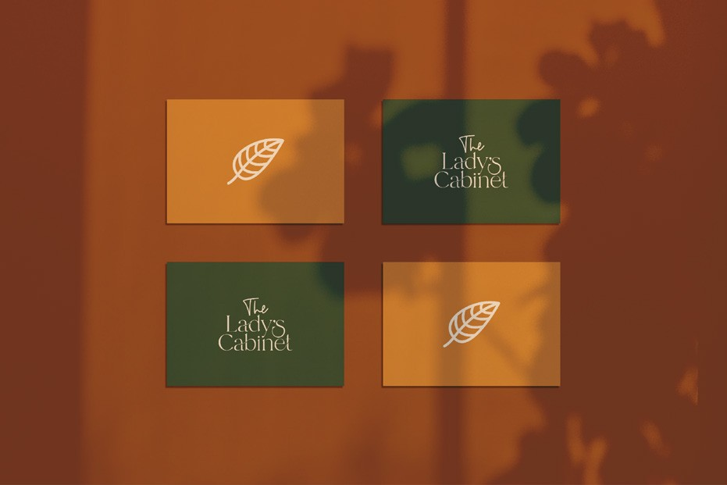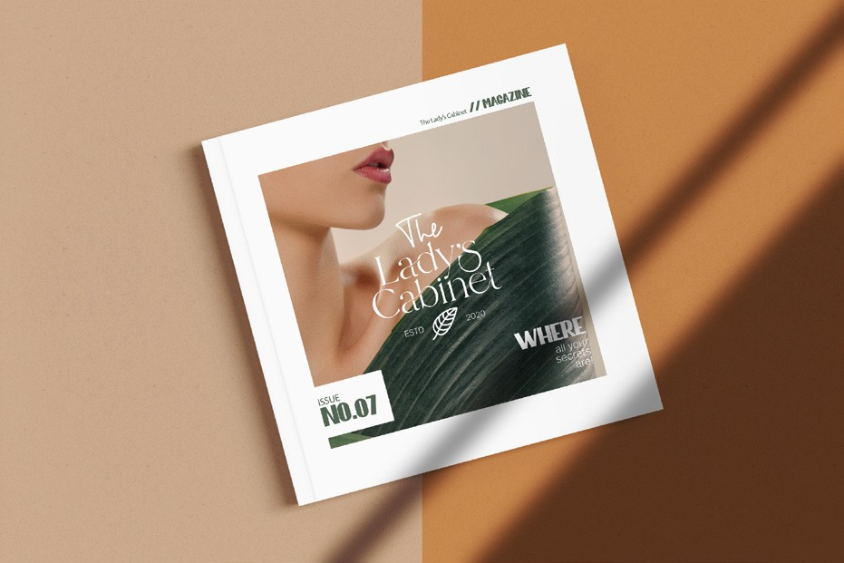

**Home About Work Contact**

**The Lady’s Cabinet** Where all your secrets are!

**Each work has** You can imagine how stuck is the beauty mark! The Saudi company

**its own mark,** provides personal care products, cosmetics, all ladies belongings, it’s called “The Lady’s Cabinet”.

**We created a specific,**

Strategy to move with The Lady’s Cabinet mission forward and build that markable beauty impact. We built a feminine effect, sending “The Lady’s Cabinet” messages, and presenting meaningful values. Classicism & Zeitgeist together! A mixture that expresses ladies and their aesthetic needs.

**Origins of the logo?**

Creating The Lady’s Cabinet visual identity takes a part from nature! Logo Construction inspired by the green leaves of spring! the naturel icon mixed with the custom type that was carefully created to blend in with the icon.

Brand identity design

01/04

**More Work**

**Doctive**

Your doctor finder

**NutCrackers**

We are nuts you are not

**Let’s talk**

Our coffee is always ready, get in touch, And kick start your brand with us!

**Abu Dhabi +971544049099**

United Arab Emirates [Email: info@blackoutae.com](mailto:info@blackoutae.com)

© 2021 Blackout Agency. Privacy Policy Terms & Condition

**Get in touch**